|  |
| --- |
|  |
| Smart Home Project |
| Name: Omar Abdulaziz Fahmy |
|  |
| **Group: L11** |
|  |

SPI

**MC 2 (Slave)**

UART

**MC 1 (Master)**

**Virtual Terminal**

* The Smart Home project consists of two microcontrollers.
* The First Microcontroller (Master) is connected to a Virtual Terminal through UART communication. The data sent from the Virtual terminal is then transferred to the Second Microcontroller (Slave) through SPI communication.
* The data received in the second microcontroller (Slave) through the SPI communication is then interpreted into On/Off switch for the connected devices, which in our case are two LEDs.

Data input to turn on the devices ( LEDs):

‘1’: Turn on LED 1

‘0’: Turn off LED 1

‘H’: Turn on LED 2

‘L’: Turn off LED 2

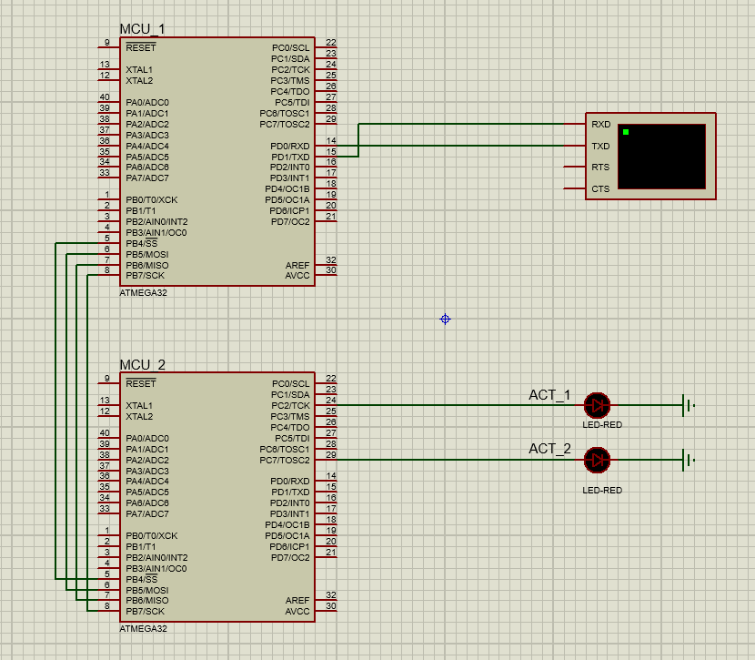

Layered Architecture:

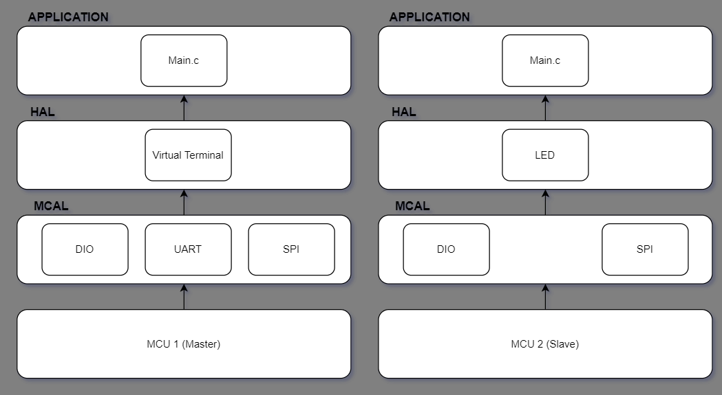Design flowchart:

